

**Expense Tracker**

Pawan Acharya, Sabin Raj Pokhrel, Ishan Narayan Shrestha, Prabin Babu Kattel

B.Sc. (Hons) Computer Science with AI

Softwarica College of IT and E-commerce, Coventry University

ST4006CEM: Computing Activity Led Learning Project 1

Module Leader: Giriraj Rawat

19th Aug 2024

**Introduction**

Expense Tracker is a GUI application that allows its users to manage and attain financial freedom. It is a functional tool to help adding, viewing and managing the personal finances adequately.

In this project, expense tracker provides users useful functionalities like adding expenses, viewing expenses and overviewing expenses. Users can add their expenses depending on their categories like food, transport, shopping, housing and others; and stores the date when they made their expenses. Additionally, users can also view their expenses data in a monthly tabular form and overview their data in a pie chart.

This project uses the Python Tkinter GUI for our user-friendly interface and sqlite3 as database system to store users and expenses information. Using our Expense Tracker, the following activities are our functional features of the application:

* Login
* Sign Up
* Forgot Password
* Add Expenses
* View Expenses
* Delete Expenses
* Overview
* Export Expenses
* Logout

In conclusion, our application lets the users to make quick and easy addition and visualization of the expenses they make.

**Aim**

The Expense Tracker uses simple logic and covers the basic tracking of the personal finances. The foremost aim of our project is to make users aware of the expenses they make and to make the everyday tracking experiences fun.

**Objectives**

The predominant objectives of our application addresses solely on simple and interactive user interface where user can utilize productive finance management and visualization. These objectives are:

1. Building an intuitive and user-friendly GUI using Tkinter that simplifies the process of entering, viewing, and managing personal expenses.
2. Giving users control over their short-term and long-term spending.
3. Enhancing the readability of the user expenses by categorizing them into different categories.
4. Letting users to export their expense table in a .csv file.
5. Storing the overall user information and their expenses in a structured database.
6. Helping to visualize the monthly expenditures in a pie-chart.

**Problem Statement**

Organizing personal expenses could be very annoying thing to do, using the classic methods of expense tracking like using physical notepad. A person can encounter input errors which can lead to incorrect financial records. There are many expense tracking applications which are complex to use which leads to inconsistent tracking that hinders financial analysis and decision making.

Our project enhances the simplicity of the tracking process by making it easy-to-use with our interactive user experience and minimal but efficient functionalities like adding, viewing and overviewing expenses.

**Features**

The project accumulates the following key features:

* Data Storage: Using this application, data can be added are stored in a database, and can be retrieved efficiently.
* Export Expenses: The expenses that are stored, can be exported in a .csv file and opened in Microsoft Excel for viewing and storing the expense information in the user’s local directory.
* Data Integrity: The application is protected from errors like invalid datatype and false information.
* Data Sorting: The data entered by the user can be sorted in a monthly basis by the date the expenses is made.

**Functional Requirements**

The Expense Tracker application is comprised of the following key features:

* Login: The Login checks if the user already exists in the database and lets them to login and access the application. If the user does not exist, then it asks them to create an account.
* Sign-up: The Sign-up allows the user to create their account if they are not registered before. If the username already exists in the database, then that username cannot be used by other users.
* Logout: The Logout allows the user to logout from their account and redirects them into login page.
* Add Expense: Add Expense allows the user to add the expenses according to the expense item’s name, price, category and date. After listing the items, the add button stores the information in the database.
* View Expense: View Expense permits the user to view their listed expenses from database in a tabular form. The user can also change the order of the expense table which is already sorted in a monthly format.
* Overview Expense: Overview Expenses makes the visualization of the data understandable by allowing the users to view their expense information in a pie-chart, which is sorted by the categories the expenses are stored.

**Non-Functional Requirements**

The Non-Functional Requirements of the Expense Tracker includes:

* Minimal but effective GUI: The application is comprised of simple and subtle GUI which makes it easier for the users to interact with the application.
* Export .csv: While this function is not a major requirement, it allows users to export their all-time expenses and store it to be used later even when they don’t have access to the application.
* Speedy Navigation: The application is very quick to navigate as it uses Python’s Tkinter framework, and the lines of code are less compared to other application with the same core idea.
* Reliable: Users can rely on Expense Tracker as the functions written are very Pythonic.

**Scope**

Figure 1:

*Scope of Expense Tracker*

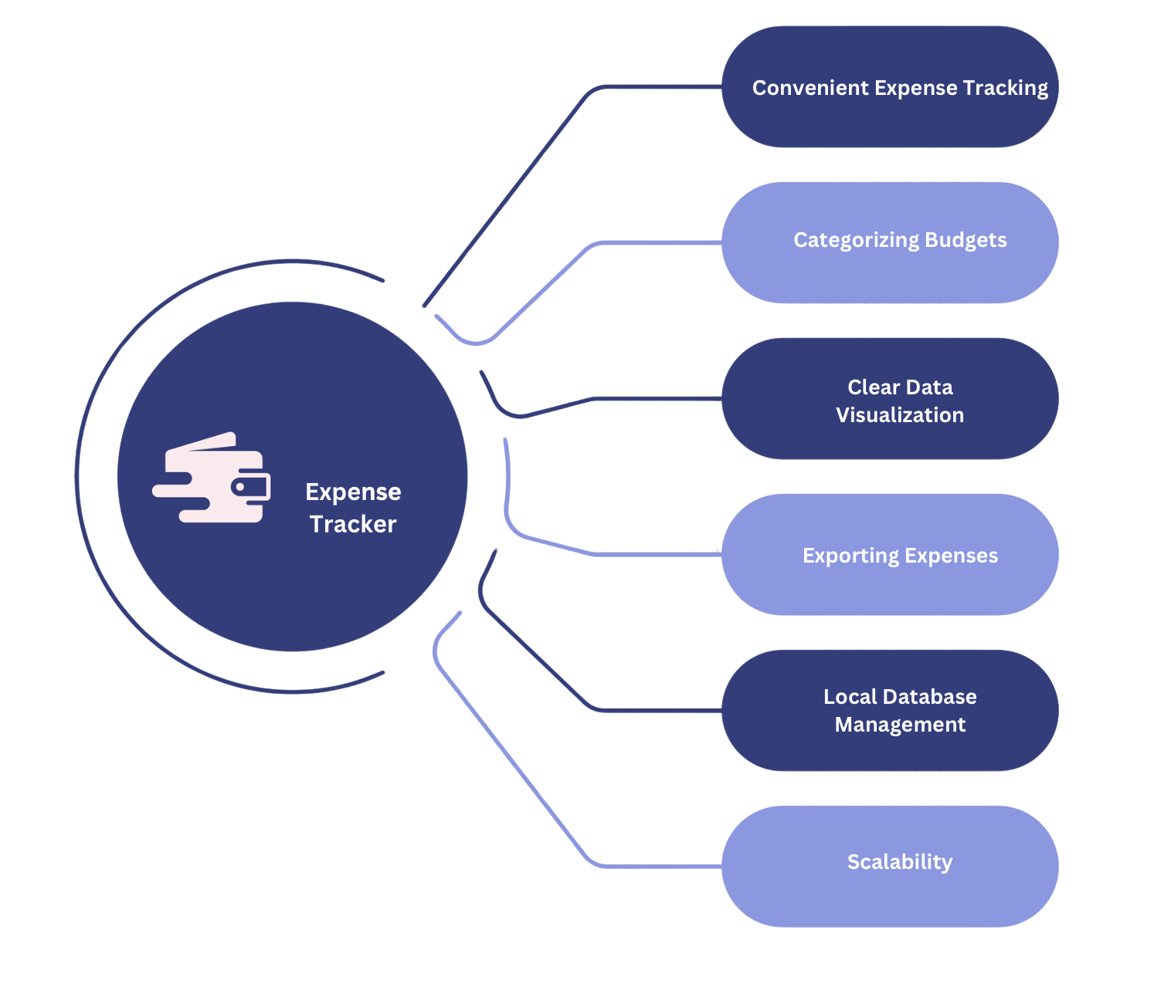

The major scope of Expense Tracker includes Convenient Expense Tracking which is possible only with our user-interface kept simple and understandable. It also includes Categorizing Budgets by categories like: Food, Transport, Shopping, Housing and Others and provides Clear Data Visualization through pie chart which makes the users to understand the expenses through category where they are spending. Furthermore, it also allows users to export their data in a .CSV file which can also be viewed in Microsoft Excel.

Finally, our project stores data locally where the data can be stored individually in user’s local directory. As the data is stored locally, the chance of data scalability is very high.

**Development Methodologies**

**Methodology**

Figure 2:

*Agile Methodology*

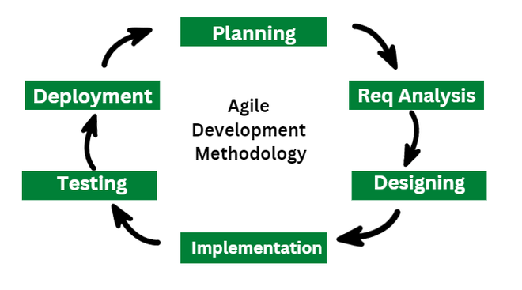

The Agile Methodology was adapted by our team to complete the development of this application. At the beginning, we gathered the requirements to build the application. We analyzed the requirements and only followed the ones that were practically important and felt possible. After, gathering all the requirements to build the application, we created a modern, subtle and eye-soothing design which was best suited for the application. We also prototyped our system design from the beginning to vision our ideas. We implemented the design and converted the prototype into a working application using Python, TKinter and SQlite3. Gradually, we tested the working mechanism of the code through some testing. We did small sprints every once-in-a-while, and in each sprint, we incremented new functionalities whilst refining the existing ones. Finally, we deployed the actual working application on GitHub.

**Tools and Technologies**

Figure 3:

*Tools and Technologies*

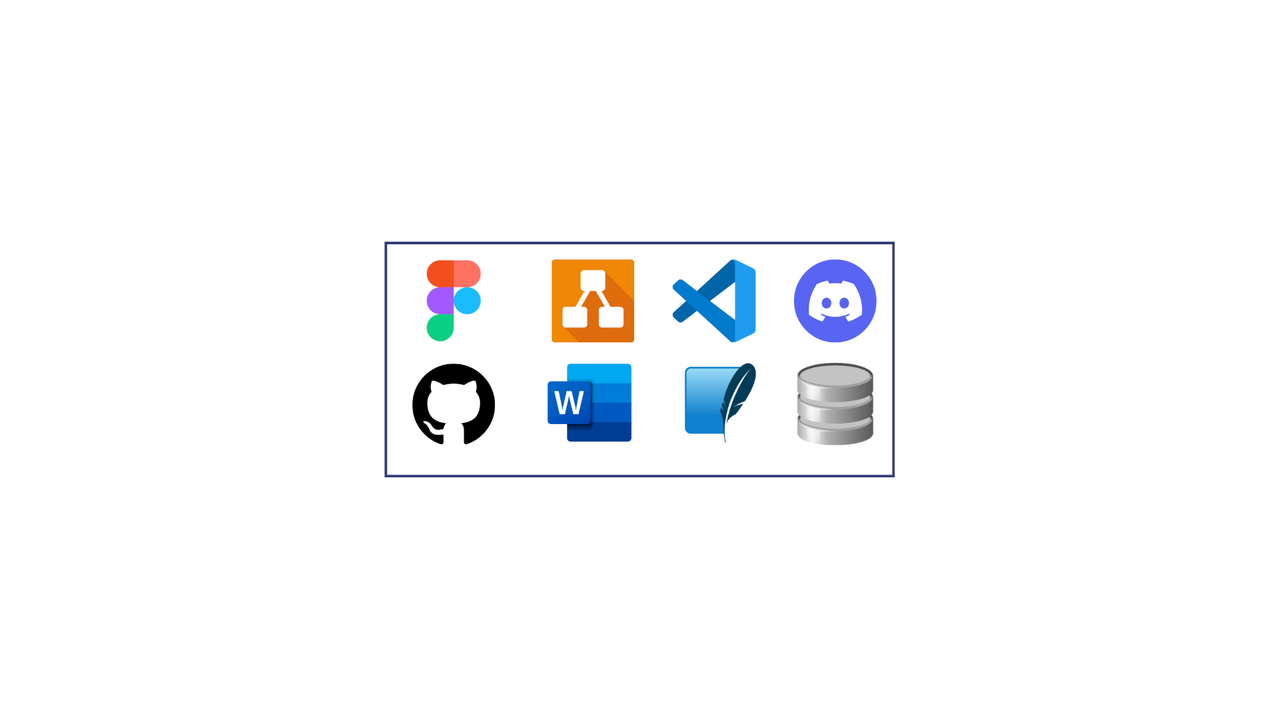

The tools that were used to complete this application are: Figma, for designing and prototyping the application; Draw.io, to create Entity-Relationship Diagrams to visualize our database; VS Code, as an IDE(Integrated Development Environment) to write and debug the code; Discord, to run sprints reviews and scrum meetings; GitHub, to push the code in a remote repository; Microsoft word, to document our application; Sqlite3, to store the user information and expenses information and DB browser, to view the data information.

**Conceptual Diagram**

Figure 4:

*Entity-Relationship Diagram*

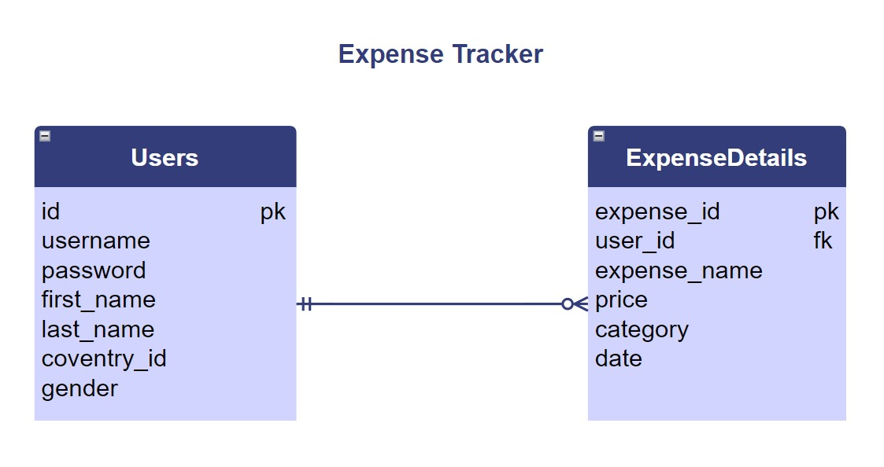

The diagram above is an Entity-Relationship Diagram of our Expense Tracker’s database showing the relation between the users and the expense details table.

**System Architecture**

In the Development of the Expense Tracker application, we have utilized one-tier system architecture. The presentation layer or user interface is operated by the user on their personal computer, and the data layer or the data structure is stored or kept at the database at the local directory of the user’s computer. Having these two components in the same location represents a one-tier architecture, as opposed to a two-tier architecture. Other kinds of multi-tier architectures add additional layers in distributed software design.

Since, the database is made directly available to the user and the server of the application also resides locally, the application enables users to directly interact with the database and execute operations. Thus, user, server and database all reside locally which makes our project a one-tier system architecture.

Figure 5:

*One-Tier System Architecture*

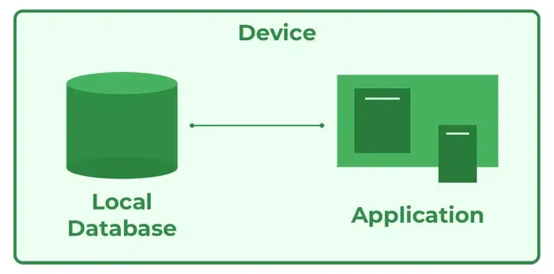

**Project Plans**

Figure 6:

*Project Gantt Chart*

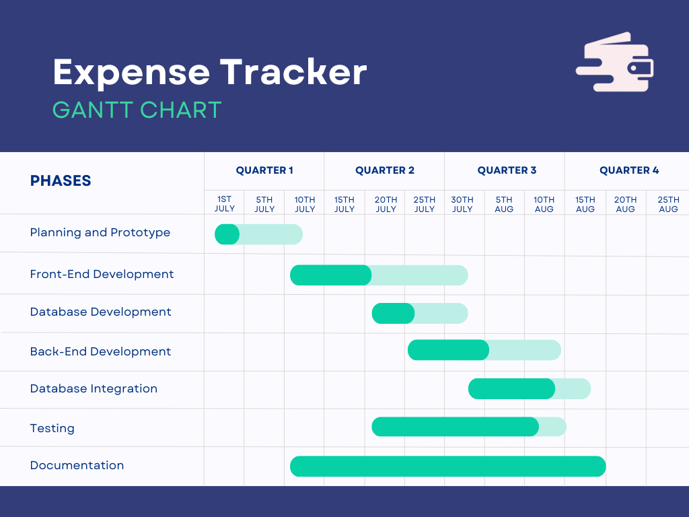

**Prototype**

Figure 7:

*Login Page Prototype*

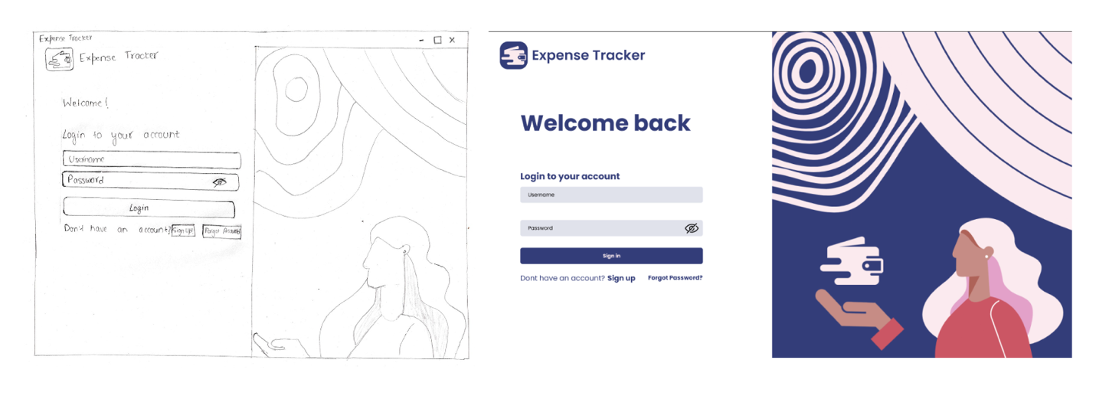 Low-Fidelity High-Fidelity

Figure 8:

*Sign-Up Page Prototype*

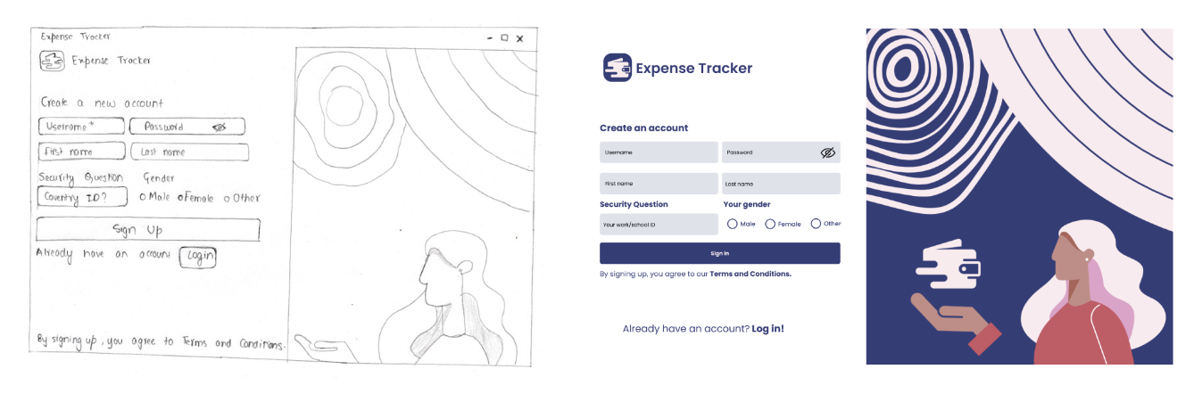 Low-Fidelity High-Fidelity

Figure 9:

*Forgot Password Page Prototype*

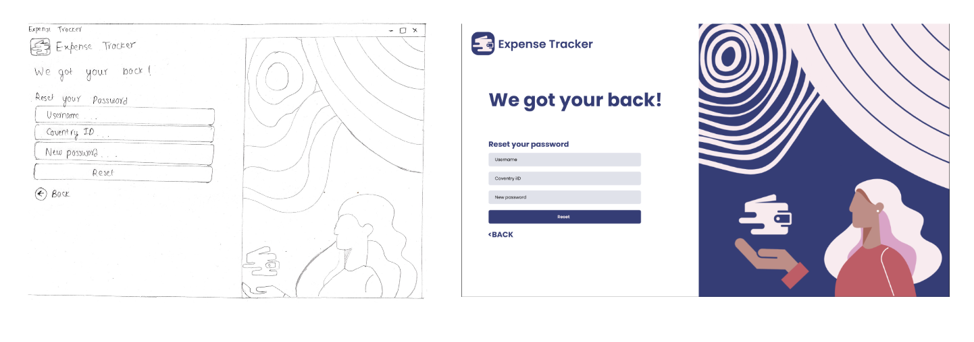 Low-Fidelity High-Fidelity

Figure 10:

*Add Expense Page Prototype*

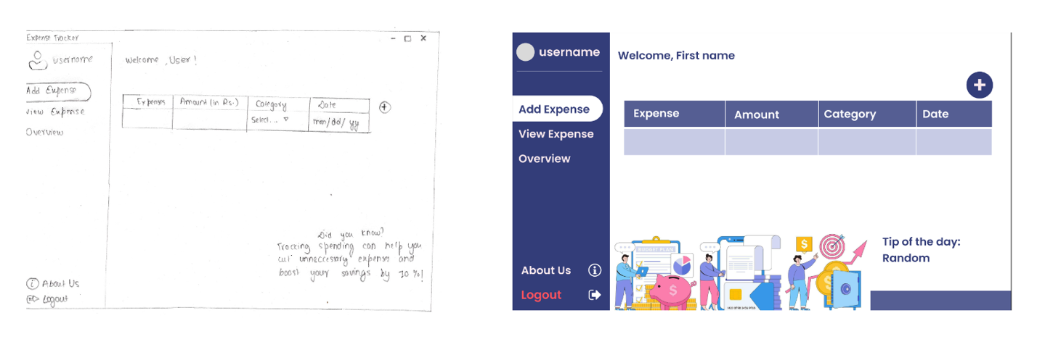 Low-Fidelity High-Fidelity

Figure 11:

*View Expense Page Prototype*

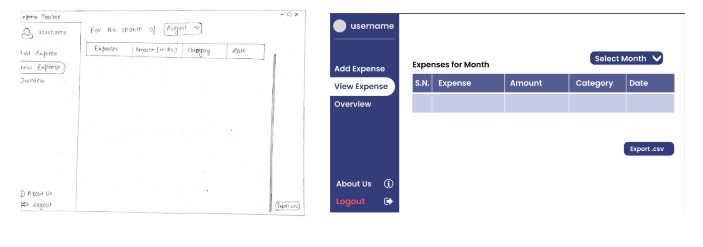 Low-Fidelity High-Fidelity

Figure 12:

*Overview Page Prototype*

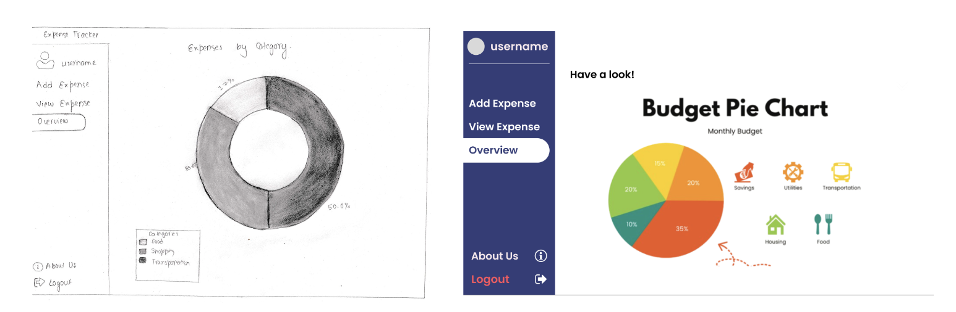 Low-Fidelity High-Fidelity

**Developed System**

**Sign-Up Page**

Figure 13:

*Sign-Up GUI*

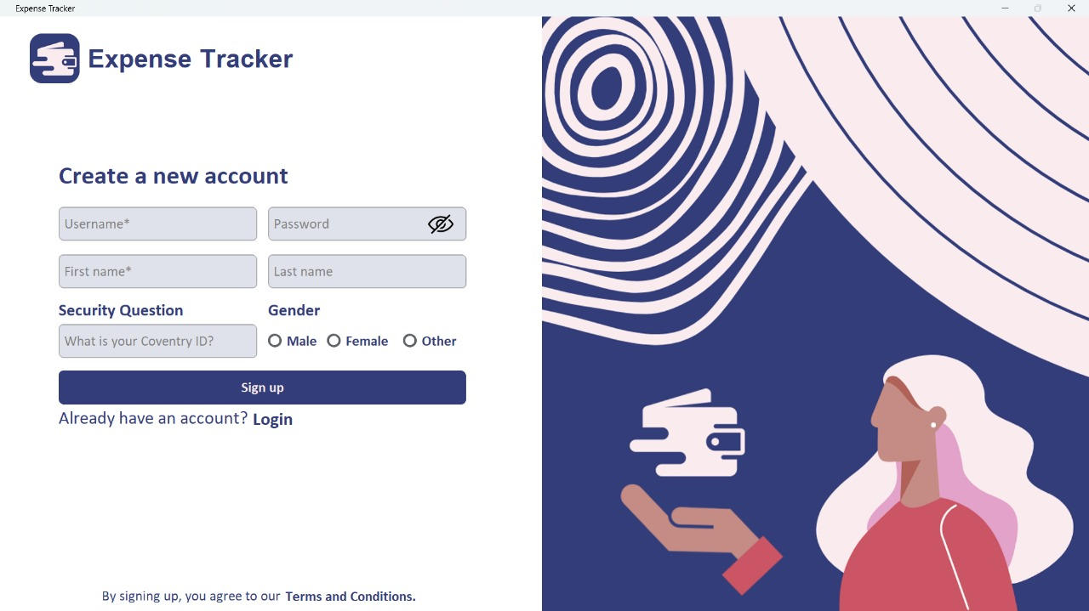

The users can create a new account entering their unique username and a password. They are also required to fill their first and last names. The Coventry ID is used as the security question which is also a required field. By signing up, users are registered in the application.

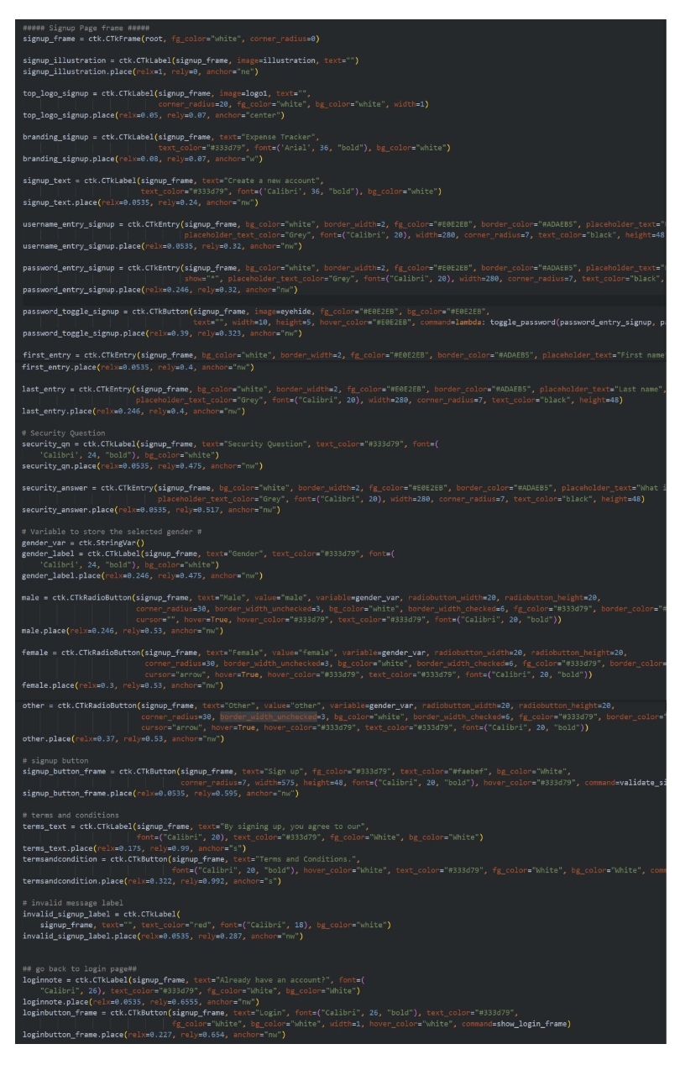Figure 14:  
*Sign-Up Code*

The above codes is the front-end (GUI) of the Expense Tracker Application.

Figure 15:

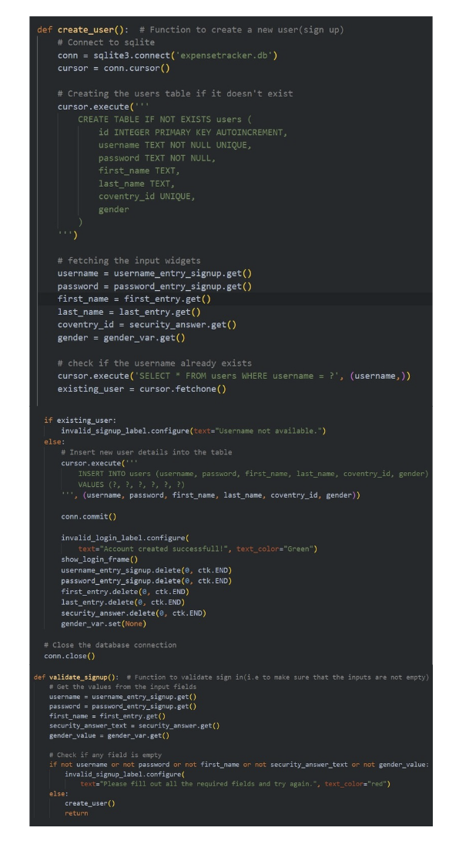 *Connecting Sign-Up with Database*

The above shown codes connects to the front-end and database, and safely stores the information provided by the user in the database.

**Login Page**

Figure 16:

*Login Page GUI*

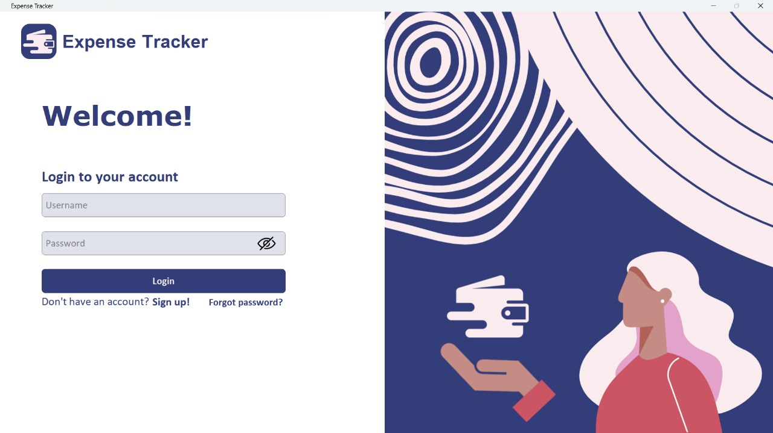

The Login Page allows the registered users to login and access the application. This is the initial page of the application which also asks the user to sign up if they have not already. Also, this page lets the user to reset their password if the respective password has been forgotten via the “Forgot password?” button.

**Forgot Password Page**

Figure 17:

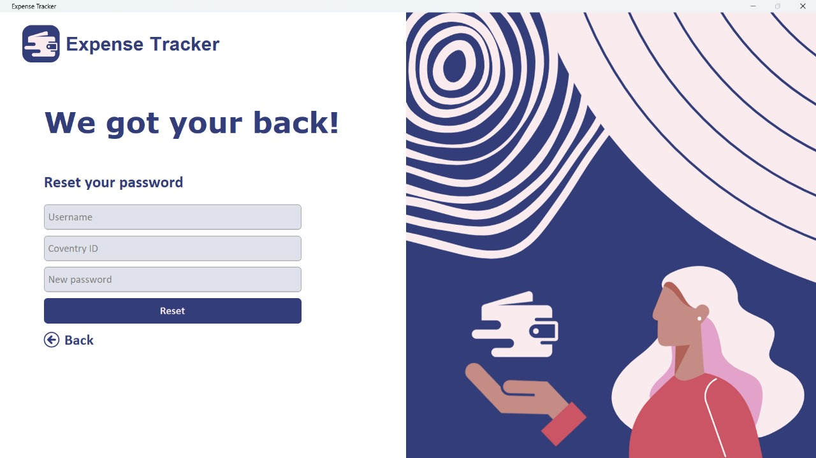 *Forgot Password GUI*

This asks the users to enter their username, and their Coventry ID, which checks if the users exist and matches the Coventry ID they provided as a security question earlier and then only, lets the user to set a new password.

Figure 18:

*Forgot Password Code:*

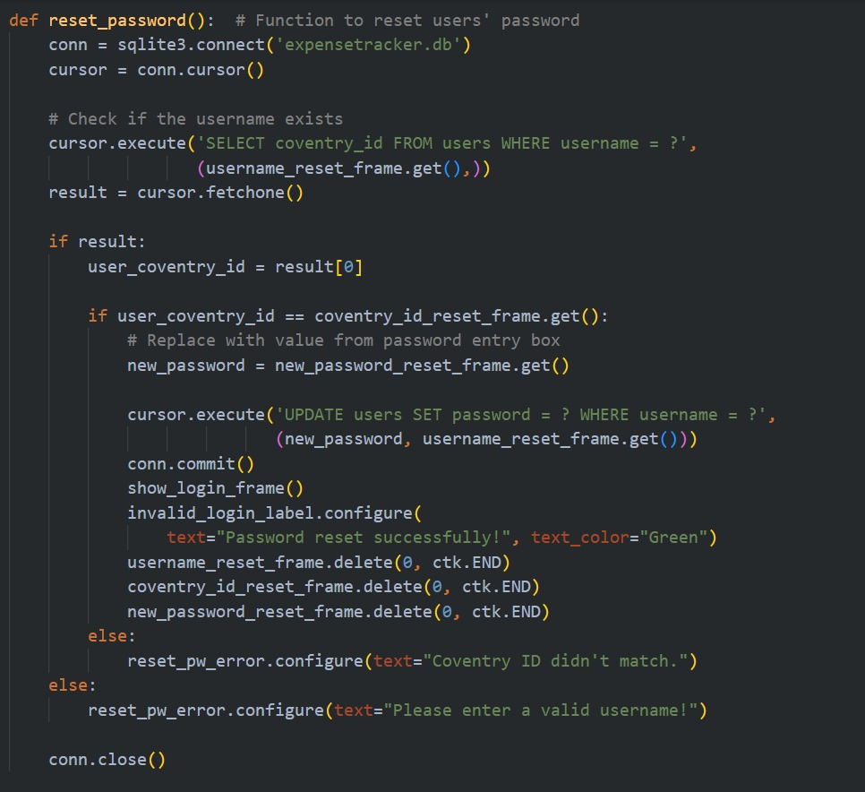

**Navigation Bar**

Figure 19:

*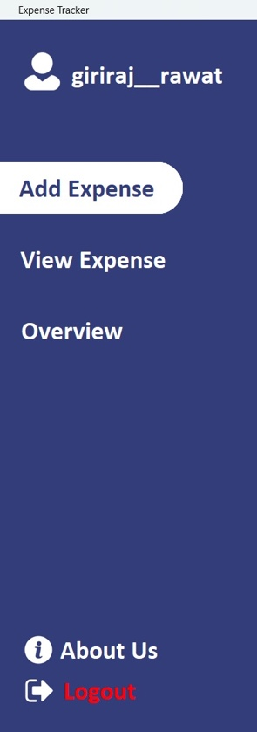Navigation Bar GUI*

The Navigation Bar allows the users to navigate through the application’s functionalities and when clicked to a desired option, the users get redirected to the desired page.

Figure 20:

*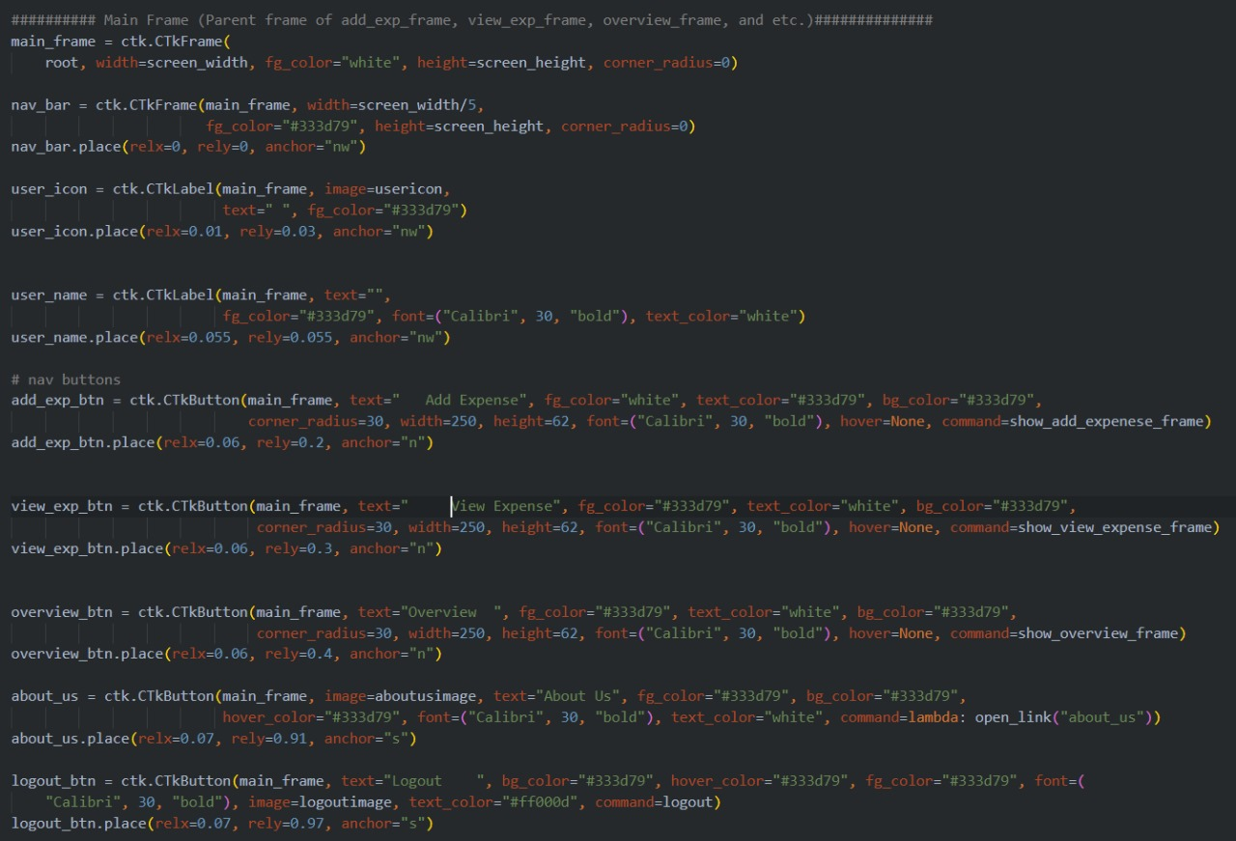 Navigation Bar Code*

**Landing Page**

Figure 21:

This is the landing page of the application after the user’s login. It is set to Add Expense as the default frame for enhanced user experience. It gives a welcome message with the first name of the user. It allows user to enter their expense in the entry field, enter the amount of the expense, select the category of the expense and the date when the expense was made. It also has a “+” button on the upper right of the page which when clicked by the user, adds the entered expense details and stores it in a database then displays the message “Expense added successfully.”

**View Expense Page**

Figure 22:

*View Expense Page GUI*

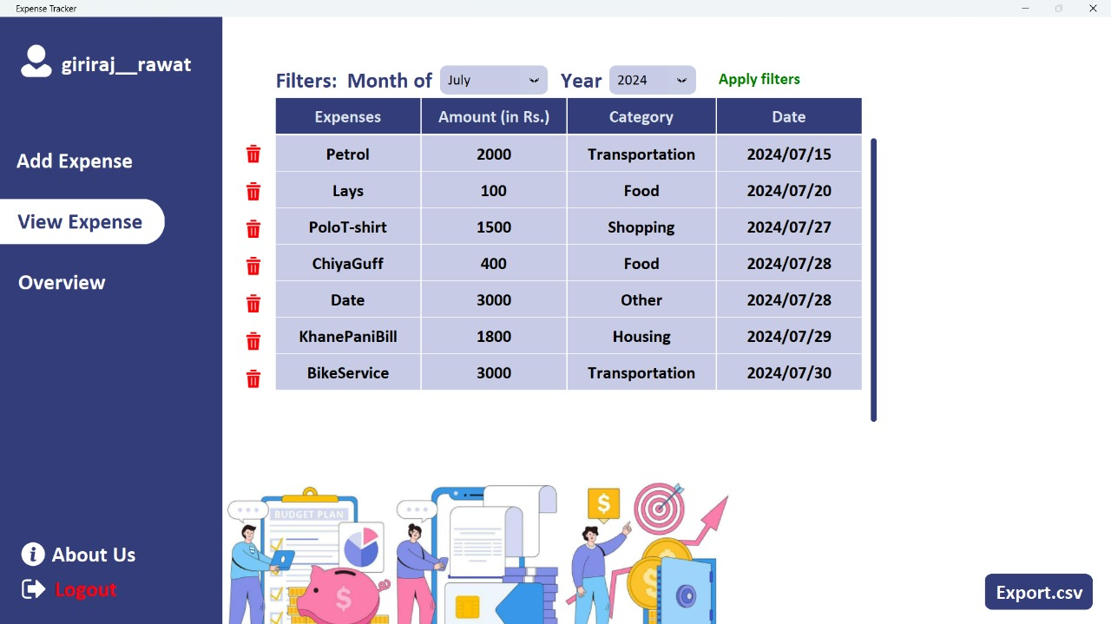

View Expense page allows the users to view the expenses they have. The expense details are sorted by the month and year the expenses are made on. The user can view their data by applying month and year filters. The month and the year filter is set to the current month and year when the app is used by default. The user can delete the desired expense details utilizing the delete feature in this page. The users can export their file in a .CSV file which redirects the users to view their overall expenses in Microsoft Excel.

**Delete Expense**

Figure 23:

*Delete Expense Confirmation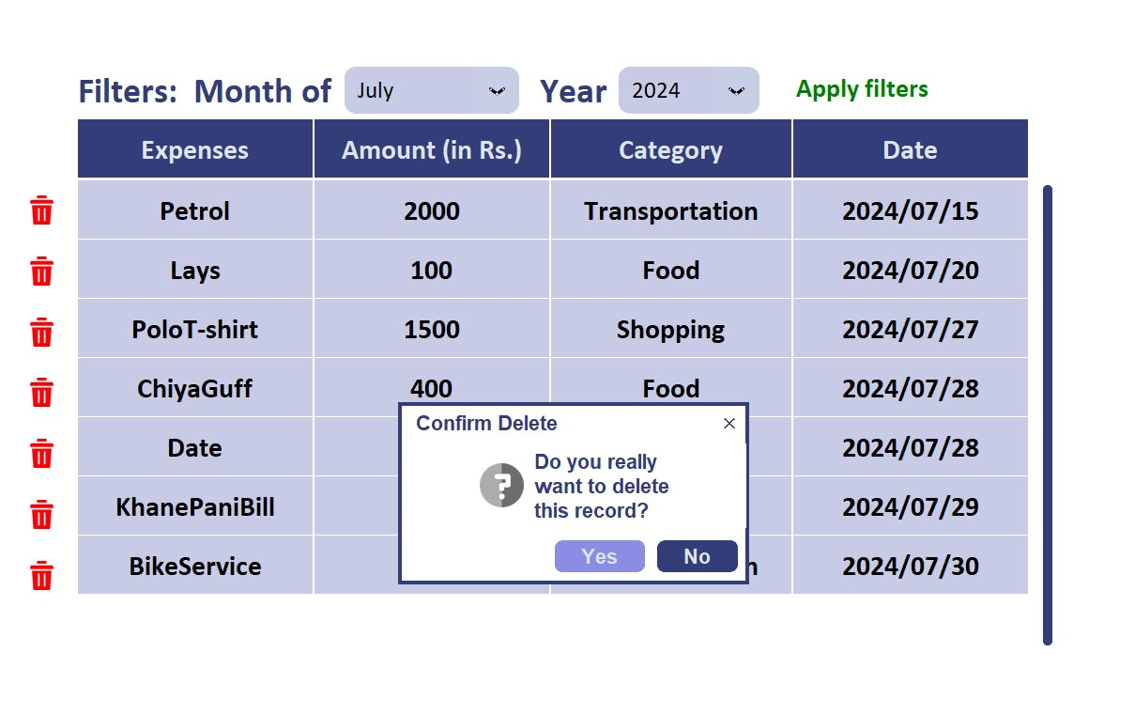*

Figure 24:

*Delete Expense Code*

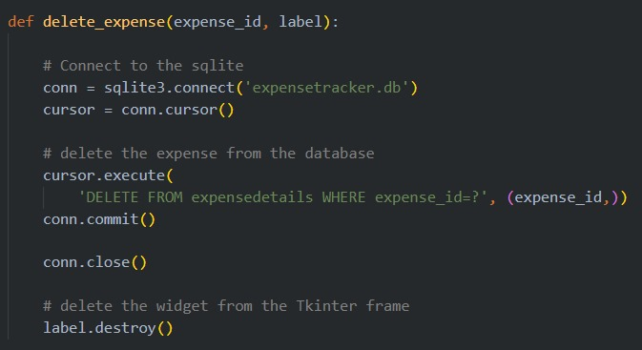

**Export .CSV File**

Figure 25:

*Export .CSV File Message*

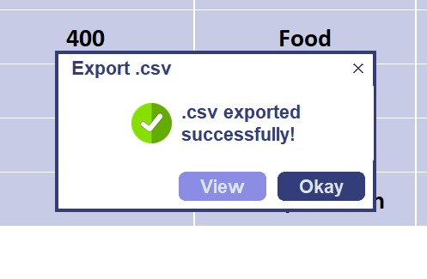

This message is outputted when the .CSV file is exported successfully. The users can also decide if they want to view the exported .CSV file right away.

Figure 26:

*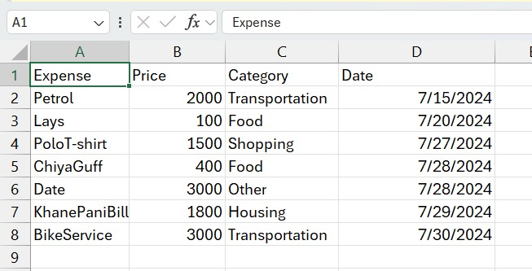 Redirected to Microsoft Excel*

After clicking on the view button, the users get redirected to Microsoft Excel with the sorted data.

**Overview Page**

Figure 27:

*Overview Page GUI*

This is an additional feature on our application which allows the users to visualize their expenses on a pie-chart. The pie-chart represents the expense details by their category and the amount spent on them. This can be a very significant feature for those who are visual learners.

Logout

Figure 28:

*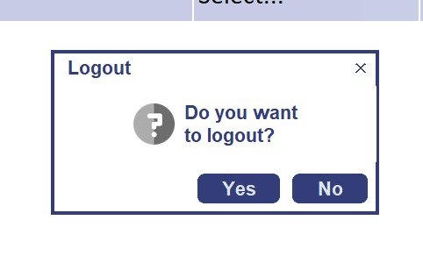 Logout Page Confirmation*

This appears when the user clicks on the logout button. It asks for the confirmation to logout. When clicked on Yes, the user is again redirected into login interface.

Figure 29:

*Logout* *Code*

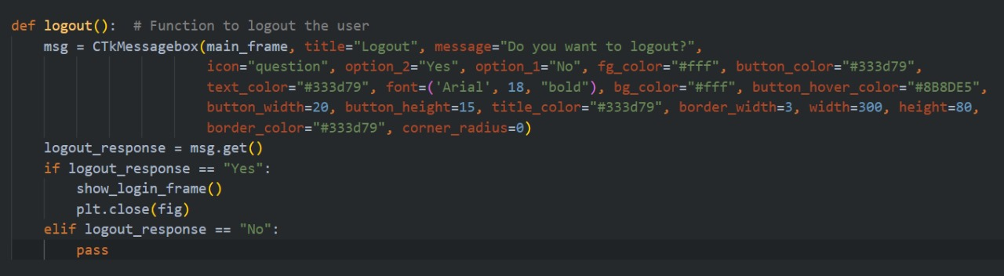

**Testing**

Manual testing was done to Expense Tracker to check the accuracy and determine the functionality of the system. Various tests were done for various conditions and the output was noted with the help of MS Excel.

Figure 30:

*Login Testing*

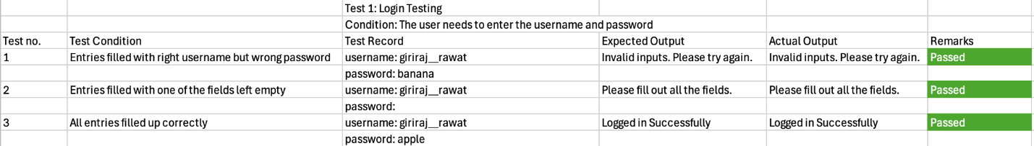

Figure 31:

*Sign-Up Testing*

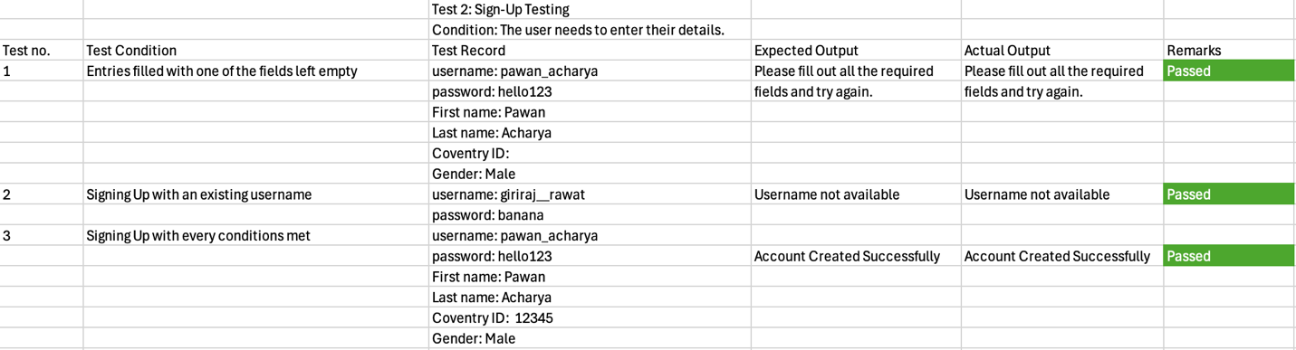

Figure 32:

*Add Expense Testing*

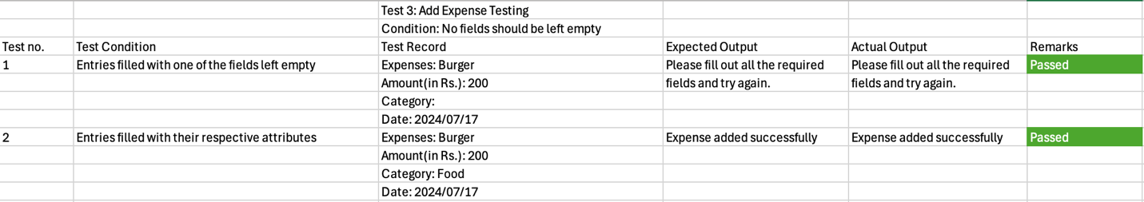

Figure 33:

*View Expense Testing*

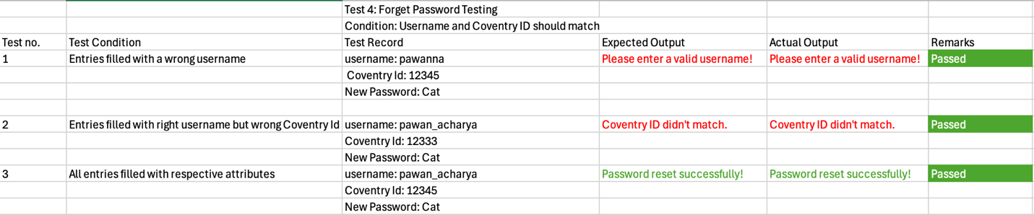

**Conclusion**

Expense Tracker is a simple but powerful application developed to simplify managing personal expenses. It provides an interactive interface for tracking expenses, viewing and categorizing them, and generating insightful overviews.

Throughout the development process, we've explored various functionalities that contribute to making Expense Tracker a very helpful tool. We know that this documentation will provide clear directions on how to make the most out of this application. Even if you are a beginner who is just getting started with tracking your spendings, this application will offer you the flexibility and features needed to make financial progress.

We would like our users to explore all the functionalities and take full advantage of Expense Tracker. Your journey towards better money management is just a few clicks away. Thank you for giving Expense Tracker a try.